**Food Ordering System for Rizkel Sisig**



**A System Proposal Presented to a Man**

**Starting a Business in Sto. Nino, Carmen**

**In Partial Fulfillment of the**

**Academic Requirements for the Subject**

**IS104 – System Analysis and Design**

**Acmali Ampuan**

**Anthony Verdida**

**Jessie Cosinas Darlo**

**Mikael Meliton**

**March 2021**

ACKNOWLEDGMENT

This project would never be made if our professor never allowed us to build a system. We had used our learnings about programming applied to this project.

We give very much thanks to our professor; He is Mr. Raffey S. Belleza who gave us an opportunity. We also had teamwork to help our member who wants to run a business.

We are and he is very happy to build the system that benefits the business of our guy. This research made us ready to face another research.

DEDICATION

First of all, we will dedicate this study to our almighty God who gave his strength and acknowledges for our everyday life.

We the researchers dedicate our research paper to our family a special feeling of gratitude to our beloved parents and also to our professor who allowed us to use our skills in making/building a system.

The completion of this undertaking could not have been possible without the participation and assistance of the members conducting the research, whose names may not all be enumerated their contributions are sincerely appreciated and gratefully acknowledgment, however this group would like to express their deep appreciation and indebtedness to all the professors in Northlink Technological College for still teaching and instructing even in the center of the pandemic.

TABLE OF CONTENTS

ACKNOWLEDGEMENT i

DEDICATION ii

LIST OF TABLES iii

LIST OF FIGURES iv

1 CHAPTER 1 7

1 THE PROBLEM AND ITS SETTINGS ...14

1.1 Background of the Study 7

1.2 Statements of the Problem 8

1.3 Scope and Limitation 8

1.4 Significance of the Study 9

1.5 Review of Related Literature 10

1.6 Context Flow Diagram 11

1.7 Definition of Terms 12

2 CHAPTER 2 14

2. METHOD 14

**2.1. Research Design 14**

**2.1.1 System Planning 14**

**2.1.2 System Analysis 14**

**2.1.3 System Design 14**

**2.1.4 System Implementation 15**

**2.1.5 System Operation and Support 15**

**2.2 Research Beneficiary 15**

**2.3 Business Profile 15**

**2.4 Research Instrument 16**

**2.5 Research Procedure 17**

**2.6 Gantt Chart 17**

LIST OF TABLES

# **LIST OF FIGURES**

**Figure 1.1 The Context Flow Diagram of Online Ordering System****...................................12**

# **CHAPTER 1**

## **THE PROBLEM AND ITS SETTING**

## **Background of the Study**

Small businesses are popular these days because this world is slowly entering a poverty state while making a business of course owners advertise their product so people can get in touch and maybe can found what they want.

Now business types are spreading, and also technology is improving to ease business things. The best small businesses that are established are ukay-ukays and food selling. This business is advertised commonly on social media and that attracts other social media users to interact and buy services and products.

Rather than going out home reserving space or time for service use, technology will be used to make things easy like online bookings. Going out of the home can make clients hassle for just doing some appointments outside to reserve for services.

There is a system built by a Computer Science student in 2015 that uses an e-menu card, this online application enables the end users to register online, select the food from the e-menu card, read the E-menu card and order food online. By just selecting the food that the user wants to have. The results after selecting the food from the E-menu card will directly appear in the screen near the Chef who is going to cook the food for you.

## **Statements of the Problem**

Students encountered the following problems.

1. Encountering sudden change of schedule orders
2. Order Deliveries is delayed due to slow process in real work
3. The establishment is closed sometimes when someone is going to buy products from just driving in the city.

**Objectives of the Study**

This study aimed to satisfy its main objective of developing an online ordering system to keep customers from going out of town, this also aimed to satisfy the following objectives:

1. To just see the menu online, pick what you want and just go

2. To automatically make the estimated delivery time for ordered goods;

3. To also list and record products ordered by recent customers, after one month the records will be automatically reset

4. Order Records will be acting as a receipt for customers

## **Scope and Limitation**

The students designed this ordering system for people that always love to buy or use something or eat for.

The System functions are in the following,

a) The customer ordering information will be recorded into the system, to be easily searched in the future when there are small problems about ordering.

b) The system can also compute how much order price has been made.

c) The system can queue orders to be delivered for fair customers that first ordered.

d) Automatically generate a customer order number

e) Only the server administration of the system can view the recorded order transactions.

f) The system operator will accept the order to manage it

## **Significance of the Study**

This system can be the key to letting hassle away from customers that love to order products and services too much.

It can also fasten the time, instantly process the customer order so they can’t wait forever, and expect the perfect time for arrival. Instead, the owner or treasurer of the business assign calculate the prices for the ordered item, the system can do the job. It also accepts easy and cashless transactions via bank cards. Also, security will be not absent for customer bank transactions of the system.

The following persons can benefit from this study:

Cashier. There will be no cashier anymore if bank transactions are relevant in use, also receipts are ready to be removed in the business.

Customer. Customers don’t need to drive in town to make face to face orders of the products.

## **Review of Related Literature**

The research of the students is all about making people who love going outside to eat food go out of the city to just order and eat foods, this is a hassle to some people that now considered relying upon the technology. The main concept of the research is the customers.

Technology today is going advanced; computers are made and it eases the work of the human lifestyle. Technology can also help humans develop more advanced and better technology, and that old model name will be the descendant of a new model name.

Computer or machines in the past are slowpokes, but it still helps human tool developing faster and the result still satisfies the operator of the machines. Technology is considered our buddy in life but others harm you from evil tech users.

Machines in the past are manually controlled by operators, this can be reliable for making more technology durable and strong to use. Slowly technology is getting smarter and smarter, it became programmable to operate automatically without the operator. But the technology can still be controlled by the operator, but once set, the machine can do the job done on its own.

There are previous studies that are already making online ordering system but various business is made by individuals to start their own.

It was stated by (Kadye Trevor) in 2015 that the online food ordering system is one of the latest servicers most fast-food restaurants in the African world are adopting. Many businesses in the world now rely on the internet thing. Also, it was stated that communication is now needed everywhere even we are far from each other, as the world population is growing.

Manual and Automation operation is explained by the researchers of SOUTHVILLE INTERNATIONAL SCHOOL & COLLEGES.

Manual data processing mostly contains inaccurate and insufficient sharing information. Through this method, it's hard to provide quality service to the customers. And when the same data exist in different files, updates cannot be done easily. In Automatic data processing, the data entering speed is high, a large amount of data can be entered and process within a short period of time.

([Brahmi Krishnamoorthy](https://www.quora.com/profile/Brahmi-Krishnamoorthy), 2020)

## **Context Flow Diagram**

The Context Diagram also includes the people or customers and also the organization who help start the business of an individual. It also contains the data the system produces and the data that the system receives from inquiries from outside. The entire system Record and Process the activity that the user made, the system will be watched by the operator to accept the order.

In **Figure 1.1**, are the entities that send and receive information from the system are included in the Context Diagram. After ordering a product, the system will pend the customer transaction and then process the order and its delivery.

Recent order activities will be stored in the system, it will act as a history receipt for customers that have concerns in the future record will be reset after 1 month. The recent order activity can be also given to the customer.

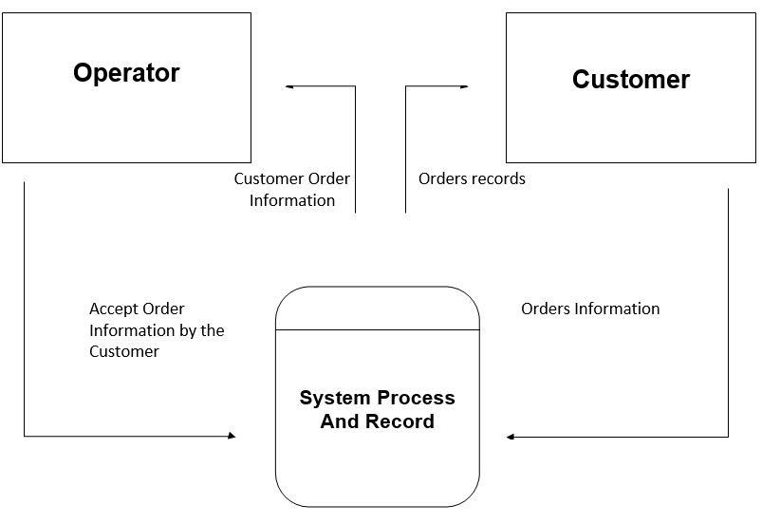

**Figure 1.1 The Context Flow Diagram of Online Ordering System**

## **Definition of Terms**

The following term used in this study are defined conceptually for clarity and easy understanding of the concepts.

*Order Information*. The information that has been provided by the customer is included here and will be passed over the system to examine

*Order Records*. After the order is accepted by the operator it will be automatically processed by the system

*Operator*. This guy will have to keep watching all the received information in the system by the customer to make decision to accept it.

*Customer*. It is a person that wants to ordered his or her favorite product, information fields are provided to be filled to make record in the system.

*System Process and Records.* All calculations and processes will be made here, it will send and receive information by the customer.

# **Chapter 2**

## **METHOD**

In this chapter, the researchers discuss the research design, research beneficiary, and research instrument. It also confers the development of application software and the disadvantages of applying it.

## **Research Design**

The researchers used this kind of method model called the System Development Life Cycle (SDLC) to plan design after it is built, it will be maintained. Here are the following steps of System Development Life Cycle (SDLC):

### **System Planning**

The researchers help the owner of the business plans to build a small business and immediately want to make an interactive system for his close people to refer the business to others.

### **System Analysis**

The researchers searched for a guide and reference from big businesses systems for they will have an idea and risk of damage while making the system.

### **System Design**

As the business is just starting, the researchers made only a simple design interface for the customers, as the activity is only filling up a short electronic form to provide information while ordering. There will be an operator that will watch and manage the living system while working to grow the business to guarantee that the system will be precise, accurate and legit.

### **System Implementation**

The business is now starting, the owner of the business will hire an IT staff to take over the system to interact with the customer. The new staff will be guided and will be taken a tour of the system as it is very simple, your job is just accepting the order queue of the customer. The researchers prepared evaluation papers for each tech-savvy person to test and evaluate the system.

### **System Operation and Support**

The friend of the business owner who coded and gives birth of the system will be only called when they encounter some errors in the system.

## **Research Beneficiary**

The proposed Food Ordering System will be given to the owner of the business.

This will help the owner to advertise his business and get many customers, this can also can quickly grow and make his business big, very big that he can build more franchises, branches in every landmark. If this happens, the system will be upgraded to be used in every specific branch location, for example; the system will be having an option that has the other branch location in the Philippines, this branch location will be selected where the customer is living with the location.

## **Business Profile**

The small business is created by two couple that has both have entrepreneurship characteristics in life. The 20-Year-Old boy name Mikael had great cooking skills; he can cook mouthwatering dishes but a dish named “Sisig” in Pinoy is his specialty. While the girl named Riza has great entrepreneurship characteristics in life and her main goal is to build a business for a better life for her husband and family in the future.

This “Sisig” dish a popular Filipino dish, this dish has a composition of sliced meats of pork, also sliced beef and fish are available for use as a substitute for meat ingredients. Sisig can be also partnered with rice, if you eat Sisig with rice it can make you easily full.

This team will have to advertise the business of our member so maybe it can intrigue you to try and taste his best Sisig. We also tasted and ate his various dishes; it is delicious.

In the future, Sisig is the not the only dish that will be available, Caldereta, Adobo, Beef Steak, Barbeque will be also included in the menu, Sisig is not the only dish that Mikael is cooking.

## **Research Instrument**

The researchers used different ways in gathering more information in finding everything about the problem occurs in their manual task to the said establishment.

**Interview.** The researcher and the owner talked about the system, it made him interested as he is just starting his business.

**Library Related System Research.** The researchers have friends that already finished and made a system run. They have borrowed and gather ideas from their friend’s system.

**Net Surfing.** Also, the researchers had a trip in surfing the internet to also find more related system and gather more ideas to apply to their system.

## **Research Procedure**

After the topic talked with the business owner, the researchers came to the library to find and gather more ideas and references to apply some of them on their system. The researchers also used the Internet to find soft copy published system papers to gather more ideas.

## **Gantt Chart**

Dated on February 2021, the business owner and this partner decided to build a business. Then in March, the researchers whose friend of the business owner decided to help, plan, design, and develop a System that can help Rizkel Sisig to grow.